Lecture 1: Basics of System Design
To Learn: After knowing web dev, learn about AWS, debugging and logging, deploying & hosting, environment variables & configurations, Testing (unit & integration). Like try to deploy frontend, backend & database on EC2, (put it on github, pull that down on EC2), get a static IP, attach it. See how it works on the browser.
Some good YT videos for System Design: Arpit Biyani, Hello Interview, Gaurav Sen
Example 1: We need to build a live counter like this:
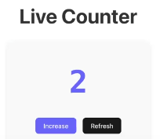
Real life usage: You tube likes, Jio hotstar live audience count, Instagram likes
Assignment 1: Try coding the same using backend and frontend, refer slide for code. Also we will need database and docker.
Assignment 2: Check how many connection does EC2/Server and databases handle?
Assignment 3: Get clear on these 10 terms
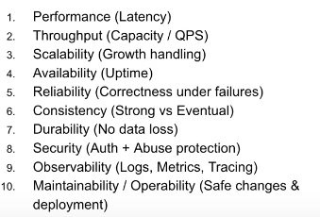
You will learn: HTTP/HTTPS basics, client server architecture, Rest API’s, Databases (sql/nosql), Authorization & Authentication, Git & version control.
A Junior engineer sees the data and following steps to build the live counter:
- API call: Get /count
- Query to db: Select * from count (server to database)
- Count = 2 (database to server)
- Server sends back the count for frontend to show
A senior engineer sees potential risks:
- What if too many users use it simultaneously: If 1 million users call Get /count, what happens?
- What if server crashes: If 100 users call it at exact same time
- What is the limit of database: If db is slow or down
- Connection issues and many more: Is count=2 always correct?
A senior engineer asks the right questions: What does the product exactly needs?
Before we solve, framing Requirement is Critical! (For any SD interview requirement gathering is important to solve questions)
A requirement is the statement that defines:
- Behaviour: what system must do, and/or
- Quality Constraints: how well it must do, and/or
- Under what conditions: Scale, failure, security, compliance
Bad: It should be fast (Never say this in the interview for SDE 2)
Good: p95 latency < 200 ms at 5k QPS (Engineers speak in these language, these are things that we should learn)
Main types of requirements (Interview View):
- Functional Requirements: feature requirements like what needs to happen, what needs to be supported, this will do this, example -
- Get /count returns current count value
- Post /increment increments count by 1
In some other cases, “Users can upload PDFs”, “Search returns top 10 results”
- Non functional Requirements: Generally quality attributes – how good the system must be (This is where seniority starts showing up)
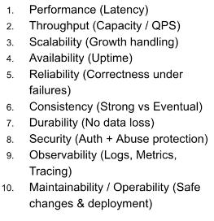
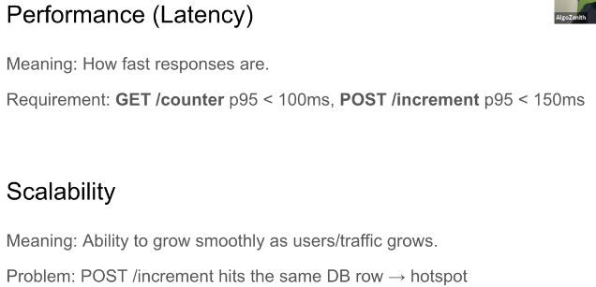
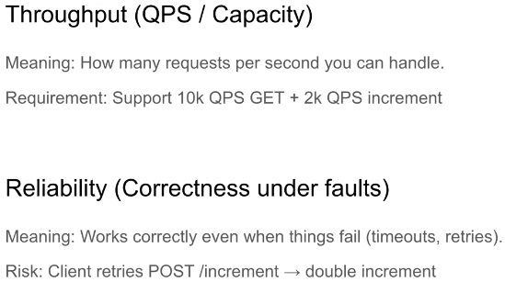

Interviewers might go deeper into one of above topics like explain how have you handled reliability in your design.
Why is reliability imp?
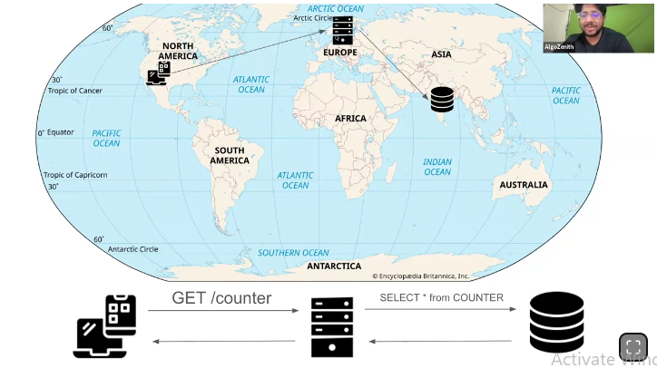
We can have user in North America, server in Europe and database in Asia. So it might time for data packets to transfer. Every arrow has a latency cost.
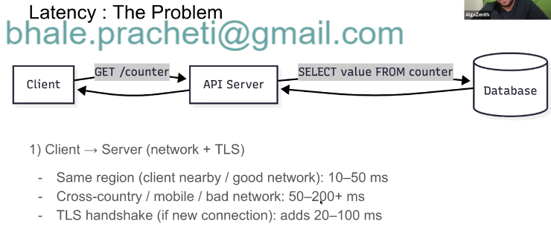

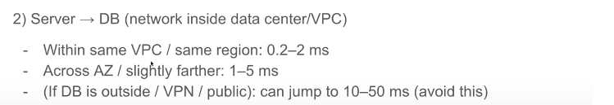
We can have server and user in the same region -
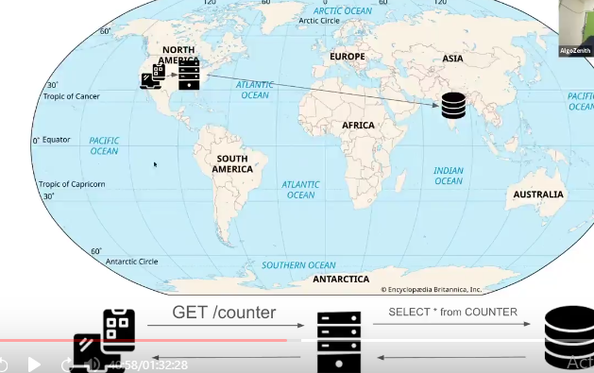
Here the TLS connection will be fast. That’s why we have multiple server across different countries.
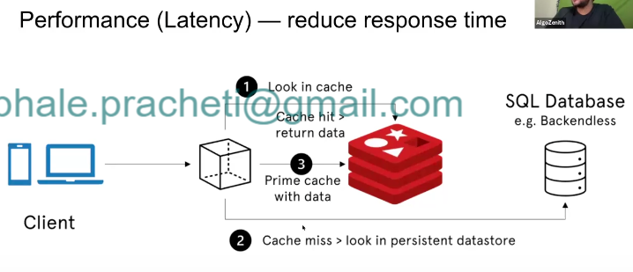
We will look later at Redis database that helps to reduce latency.

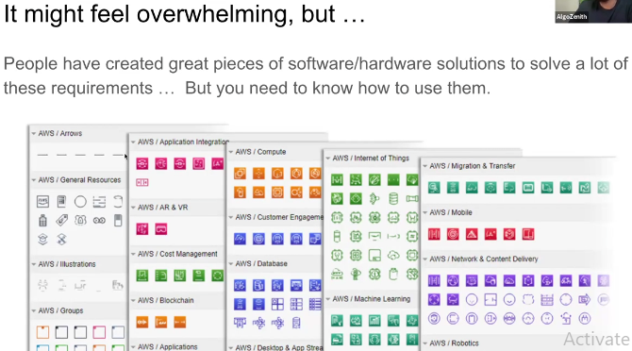

Computer foundations are must:
Example: What decides how many concurrent request a server/EC2 instance can handle
Just to Revise –
Codes get compiled into lines of code called assembly level commands that gets run on CPU cores. There can be multiple cpu cores in todays times.There can be multiple processes running the same code. We can schedule them.
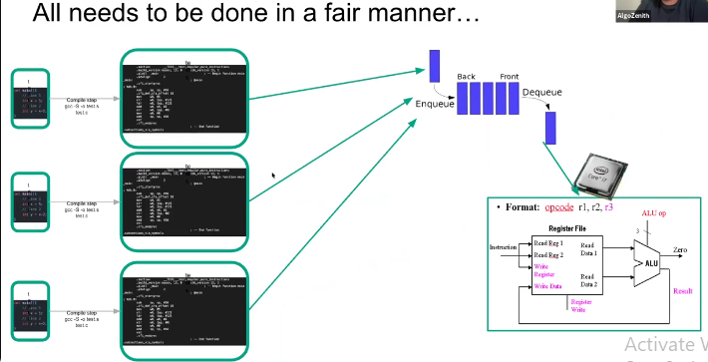
All of these problems are solved and managed by OS.
Order of studying them: (bottom up)
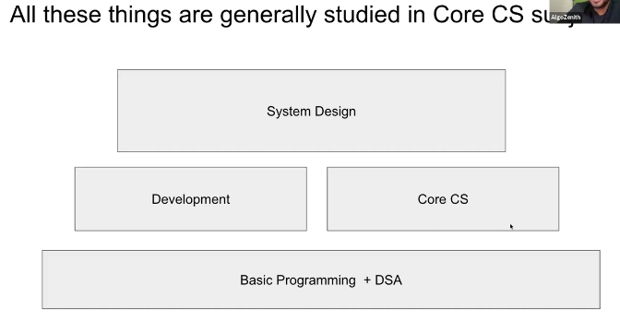

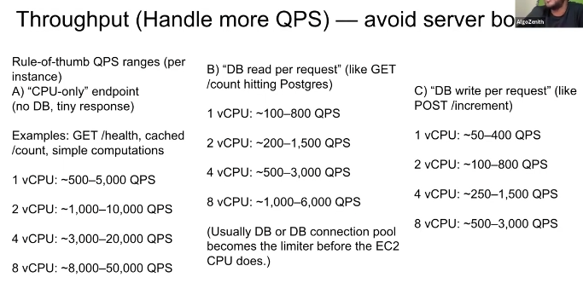
Read: cpu cores vs vcpu, hyperthreading
When we purchase cpu on EC2, its pricing is done by vcpu.
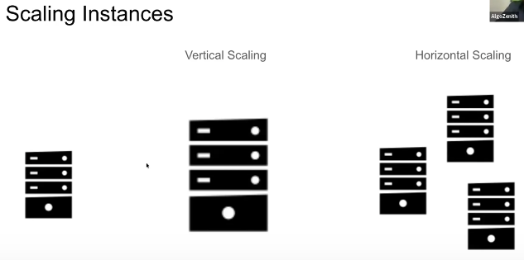
Read: Stateful vs stateless
Servers should be stateless and database should be stateful.
Load Balancing:
If we have multiple server in a country then how will we know which request will go to which server? This is decided by load balancer.
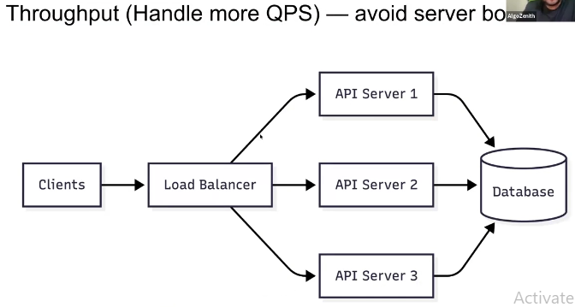
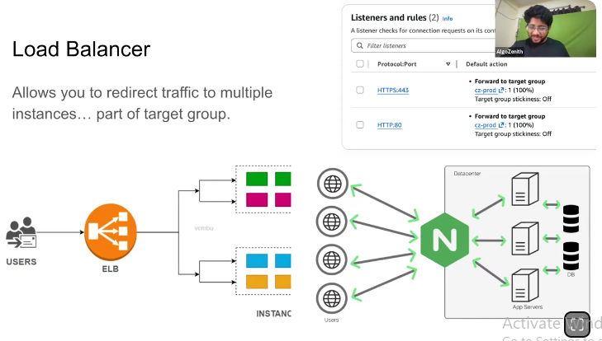
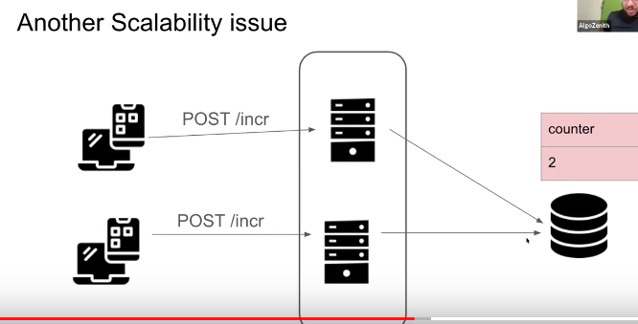

First of all database is a bottleneck, we will some kind of lock here. But we cannot even have multiple database.
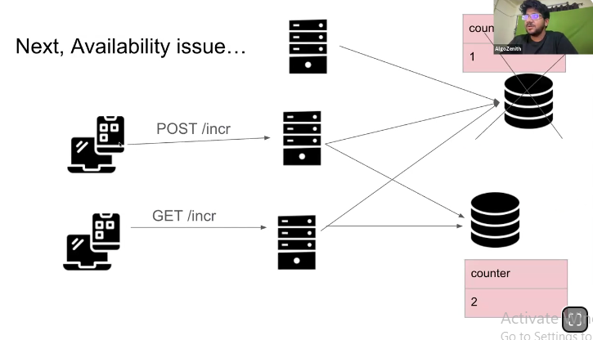
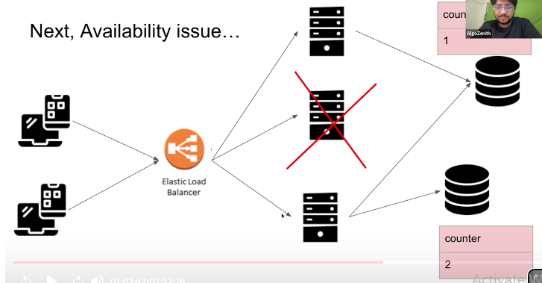
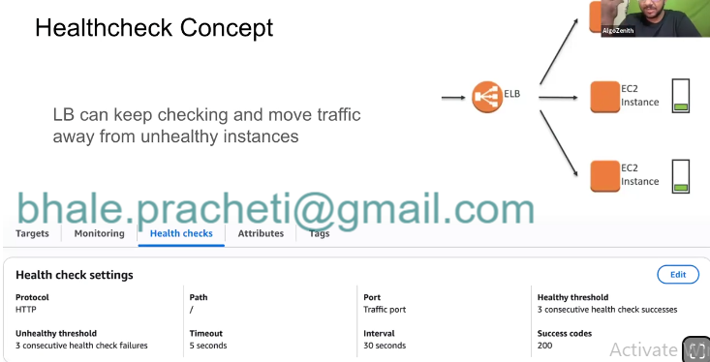
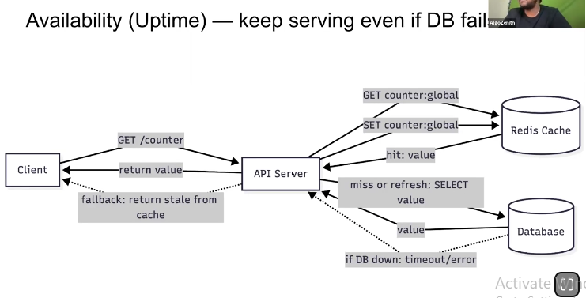
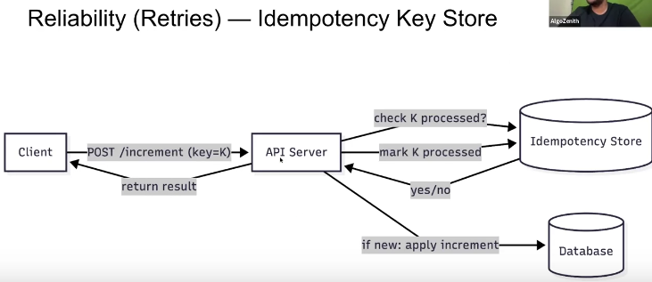
Every request has a key associated with it so first we check if the Key “k” is processed, if not then increment.
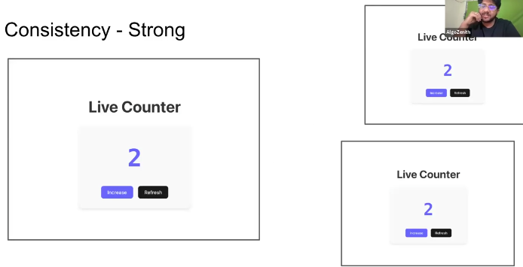
If there are 3 people opening the live counter website, should they all see the same number => Yes
If they all come from the same database then value will be same.
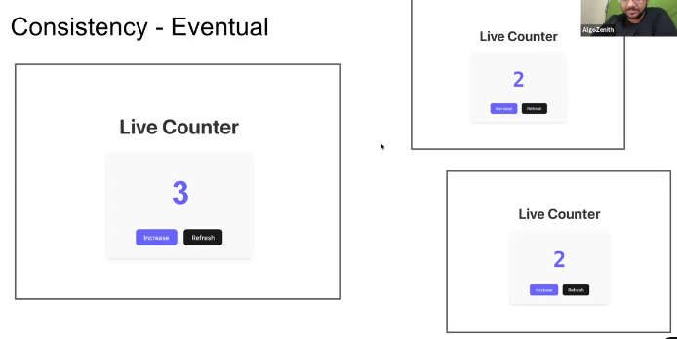
The increase takes some time to happen at other people’s UI. It takes place as follows -
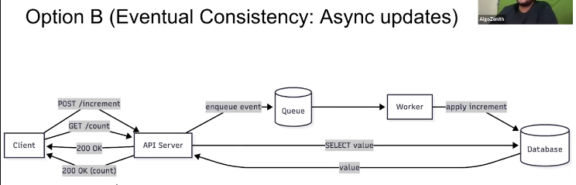
In Eventual consistency, whenever says an increment, we will save that increment inside the queue and for the user we will increase it for temporary. From the queue, it slowly gets into the database with the speed at which database can handle.
Durability comes into picture if the queue itself fails.
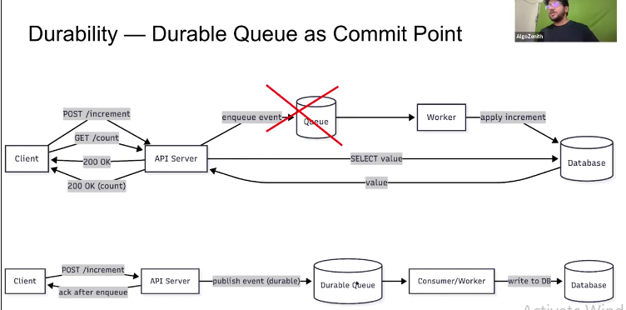
We can use Durable queue like follows -
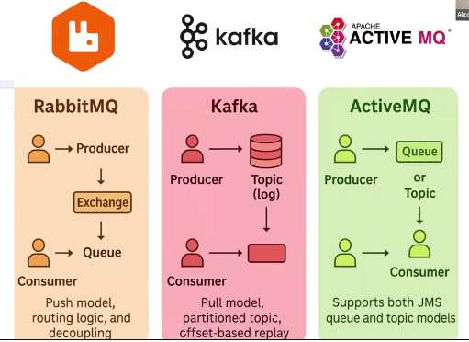

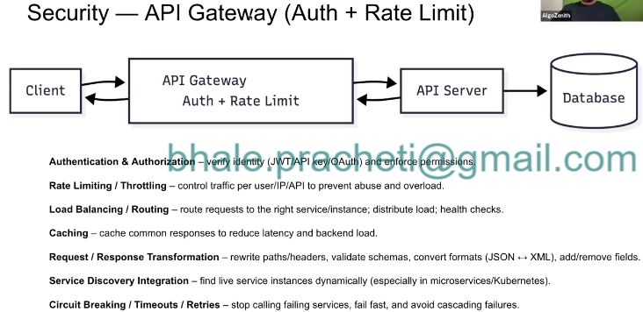

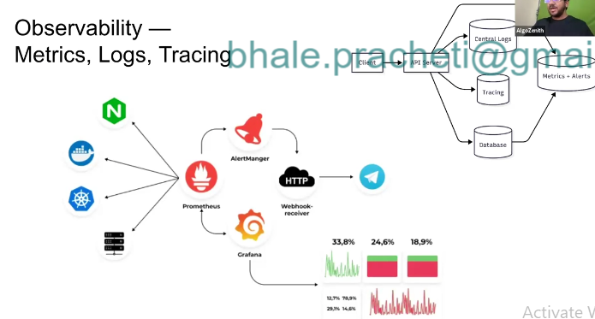
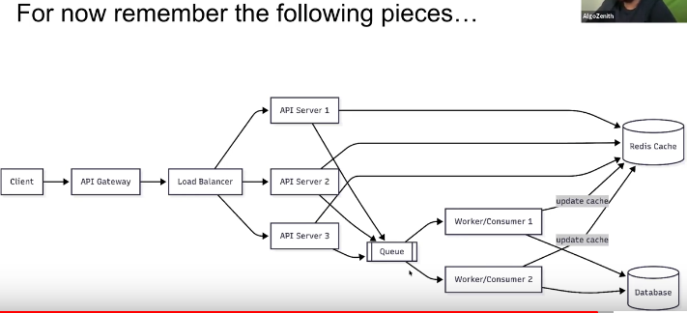

Assisgnment 1:

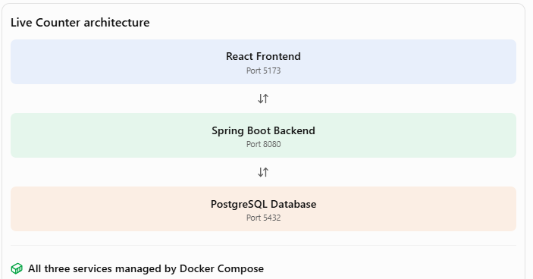
Think of them as three different workers:
- React is the person interacting with the application.
- Spring Boot is the person processing the request.
- PostgreSQL is the person maintaining the records.
They have different responsibilities, but they communicate with each other.

2. What is Docker doing here?
Normally, installing and running these applications directly on your computer would mean:
- Installing Node.js for React.
- Installing Java for Spring Boot.
- Installing PostgreSQL.
- Configuring each application individually.
Docker provides an alternative.
It packages each service into an isolated environment called a container.
Think of a container as a small isolated environment in which an application runs with its required dependencies.
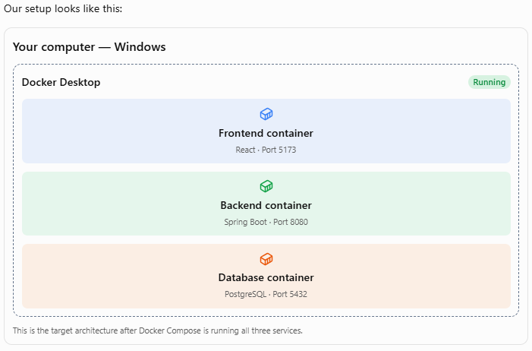
Each container runs independently, but Docker creates a private network that allows them to communicate.

3. How do these services communicate?
This is the most important part.
Docker Compose creates a network for our application.
Within this network, each service can communicate with the others using its service name.

4. How do we see the application on localhost?
This is another important concept: Port Mapping.
Imagine the frontend is listening on port 5173 inside Docker.
Docker makes it accessible through port 5173 on your Windows machine.
URL | What you access
http://localhost:5173 | React application
http://localhost:8080/api/counter | Spring Boot API
localhost:5432 | PostgreSQL port (not a browser page)

5. What happens when you click Increase?
Let's follow the complete journey.

Increment request flow
- You click Increase
React executes the incrementCounter() JavaScript function.
- React sends an HTTP POST request
POST http://localhost:8080/api/counter/increment
The browser sends the request to the backend through the published port.
- Spring Boot receives the request
CounterController receives it and calls CounterRepository.
- PostgreSQL updates the record
- UPDATE counter
- SET value = value + 1
WHERE id = 1;
The database updates the stored counter value.
- Spring Boot returns JSON
{"value": 11}
- React updates the screen
React receives the JSON and updates its state using setCount(data.value).
Result

11
The updated counter appears in your browser.

6. Why do we need Docker Compose?
Without Docker Compose, you would have to start each service separately.
For example:
- Start PostgreSQL.
- Start Spring Boot.
- Start React.
With Docker Compose, you define all three services in one configuration file.

